DELEGATION OF AUTHORITY AND FINANCIAL MANAGEMENT POLICY
AFRICAN SOLIDARITY CIVIC ORGANISATION (ASCO NPC)
DOCUMENT STATUS | APPROVAL AUTHORITY
Effective date: 06 September 2026 | ASCO Board of Directors

1. PURPOSE OF THE POLICY
The purpose of this policy is to establish a clear governance framework that separates the responsibilities of the Board of Directors from the operational responsibilities of executive management.
This policy ensures that ASCO maintains:
•Accountability;
•Transparency;
•Effective financial management;
•Proper internal controls;
•Compliance with donor, regulatory and governance requirements.

2. GOVERNANCE PRINCIPLE
ASCO adopts the principle that:
The Board governs, while Executive Management manages.
The Board of Directors shall provide strategic direction, oversight and accountability, while the Executive Director shall be responsible for the implementation of approved programmes and the daily administration of the organisation.

3. ROLE OF THE BOARD CHAIRLADY
The Chairlady, Ms. Busisiwe Makhosi Shandu, shall serve as the highest governance oversight authority of ASCO.
Her responsibilities include:
•Providing leadership to the Board;
•Ensuring effective governance practices;
•Monitoring organisational performance;
•Ensuring accountability of executive management;
•Chairing Board meetings;
•Ensuring that ASCO complies with its founding documents and legal obligations.
The Chairlady shall not be responsible for daily financial administration to maintain independence between governance oversight and operational management.

4. EXECUTIVE DIRECTOR AUTHORITY
The Board delegates operational authority to:
Mr. Bhekisisa Shandu
Executive Director
The Executive Director is authorised to manage the daily affairs of ASCO, including:
•Implementing Board-approved strategies and programmes;
•Managing operational activities;
•Managing approved budgets;
•Authorising routine organisational expenditure;
•Engaging with donors, government departments and stakeholders;
•Managing staff, volunteers and service providers;
•Conducting daily banking and administrative transactions within approved limits.
The Executive Director shall report regularly to the Board and the Finance and Procurement Committee.

5. FINANCE AND PROCUREMENT COMMITTEE
The Board establishes the ASCO Finance and Procurement Committee.
The Committee shall be chaired by:
Mr. Khulekani Gumede
Director: People and Culture
The Finance and Procurement Committee shall:
•Provide financial oversight;
•Review financial statements and reports;
•Monitor compliance with budgets;
•Oversee procurement processes;
•Ensure value for money and transparency;
•Review financial risks;
•Monitor compliance with donor requirements;
•Make recommendations to the Board.
The Committee shall not replace the authority of the Executive Director to conduct approved daily operations.
6. PROCUREMENT GOVERNANCE
All procurement shall follow the principles of:
•Transparency;
•Fairness;
•Accountability;
•Cost effectiveness;
•Avoidance of conflicts of interest.
The following controls shall apply:
•Routine purchases: May be approved by the Executive Director within an approved budget.
•Significant purchases: Require consultation with the Finance and Procurement Committee.
•Major contracts, asset purchases or unbudgeted expenditure: Require prior Board approval.

7. BANKING AUTHORITY AND SIGNATORIES
The Board appoints the following Directors as authorised bank signatories:
1. Mr. Bhekisisa Shandu
Executive Director
Primary operational banking authority; responsible for daily financial administration.
2. Mr. Thapelo Nelson Maqalika
Director: Head of ICT and Communications
Secondary banking authority; provides continuity and digital banking support.
3. Mr. Khulekani Gumede
Director: People and Culture / Chairperson: Finance and Procurement Committee
Financial oversight signatory; ensures adherence to financial governance requirements.
8. FINANCIAL CONTROL MEASURES
To maintain proper internal controls:
•The Executive Director may process operational payments within approved budgets.
•Payments requiring additional approval shall require a second authorised signatory.
•No single individual shall exercise unrestricted control over ASCO finances.
•Financial reports shall be submitted regularly to the Finance and Procurement Committee and Board.
•All expenditure must be supported by proper documentation.
9. ACCOUNTABILITY AND REPORTING
The Executive Director shall provide:
•Monthly operational reports;
•Financial updates;
•Programme implementation reports.
The Finance and Procurement Committee shall provide oversight reports to the Board.

10. REVIEW OF POLICY
This policy shall be reviewed annually or whenever necessary to ensure that ASCO remains compliant with governance standards, donor expectations and regulatory requirements.
ADOPTED BY THE BOARD OF DIRECTORS OF ASCO NPC
The policy is adopted by the ASCO Board of Directors and takes effect on 06 September 2026.

  CHAIR LADY  Ms. Busisiwe Makhosi Shandu  Signature:  ____________________________  Date: 6 September 2026  ____________________________ |   DIRECTOR: HEAD OF ICT AND COMMUNICATIONS  Mr. Thapelo Nelson Maqalika  Signature:  ____________________________  Date: 6 September 2026  ____________________________
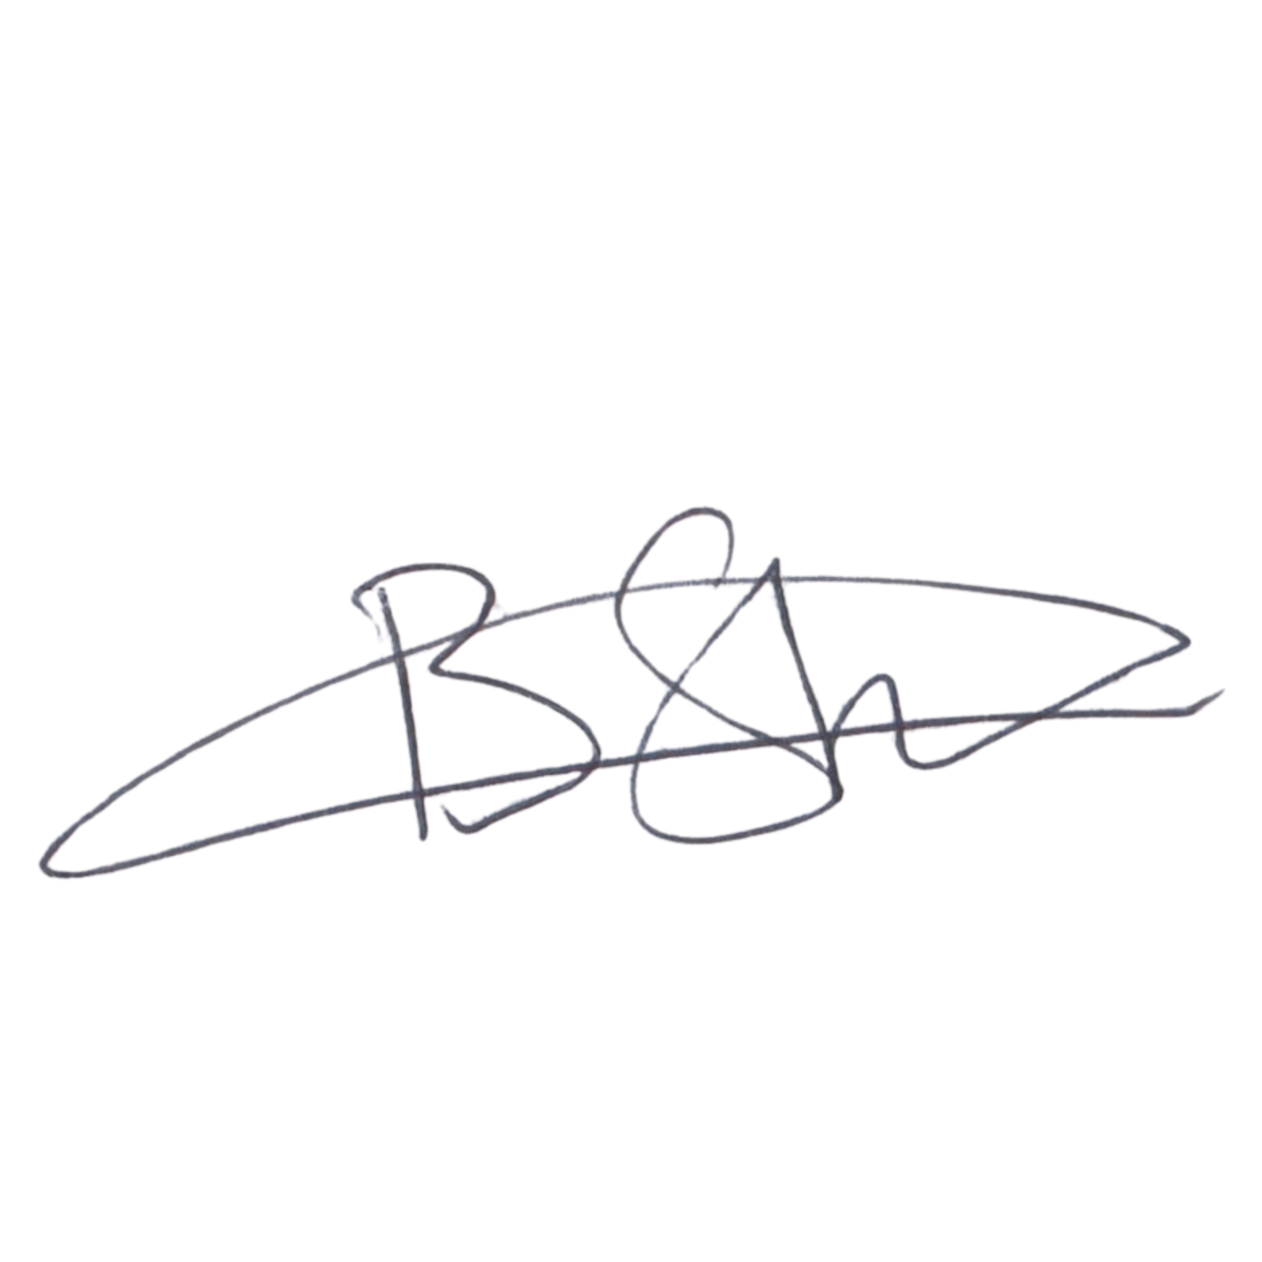  EXECUTIVE DIRECTOR  Mr. Bhekisisa Shandu  Signature:  ____________________________  Date: 6 September 2026  ____________________________ | 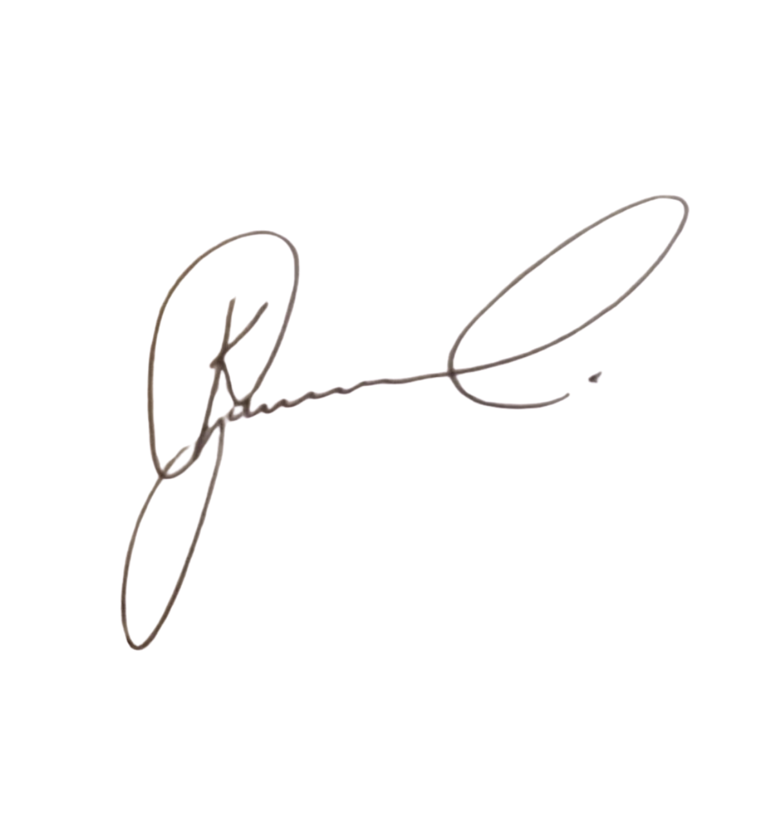  DIRECTOR: PEOPLE AND CULTURE / CHAIRPERSON: FINANCE AND PROCUREMENT COMMITTEE  Mr. Khulekani Gumede  Signature:  ____________________________  Date: 6 September 2026  ____________________________

